Complaint Form (French Creole)

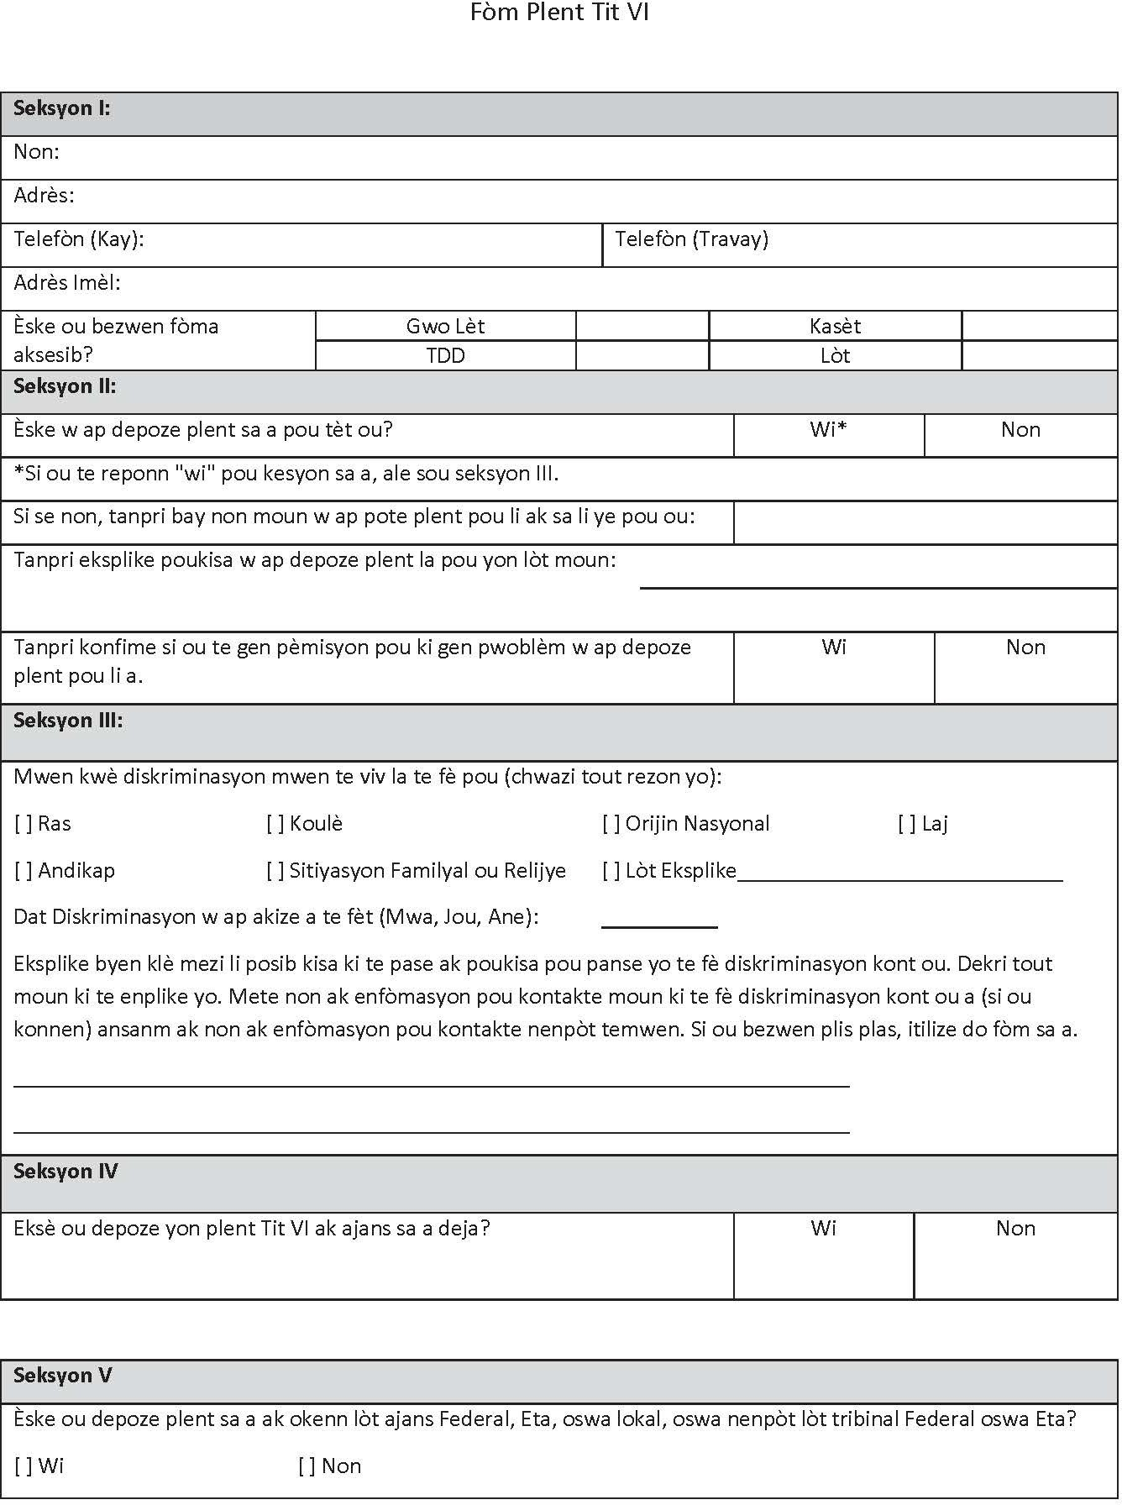

Complaint Form (French Creole)

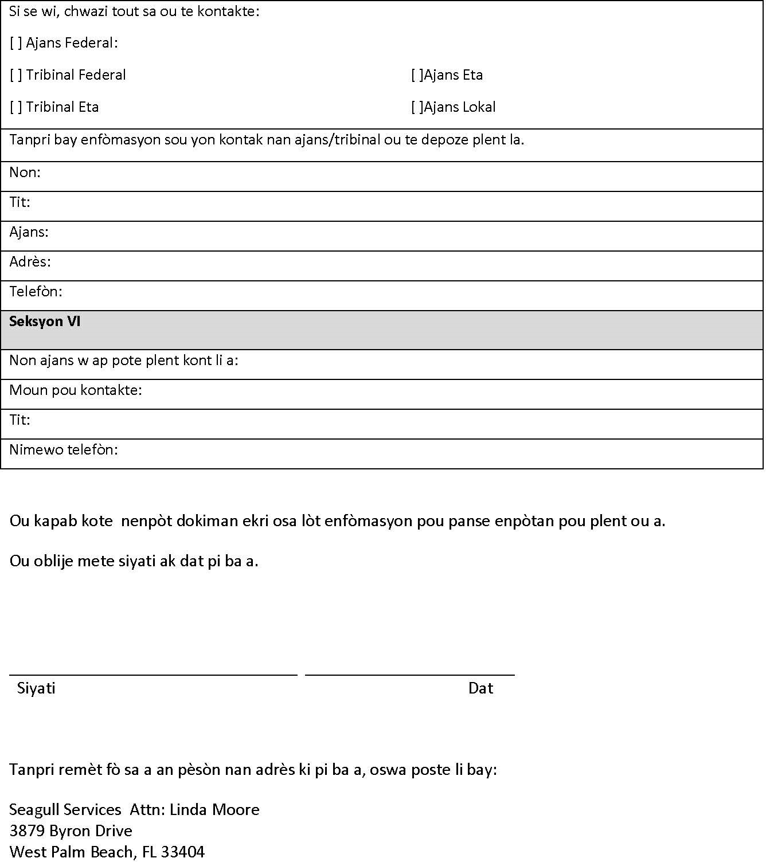

**Woodhouse**

Attn: **Title VI Liaison**

**1001 NE 3rd Ave.**

**Pompano Beach, FL 33060**